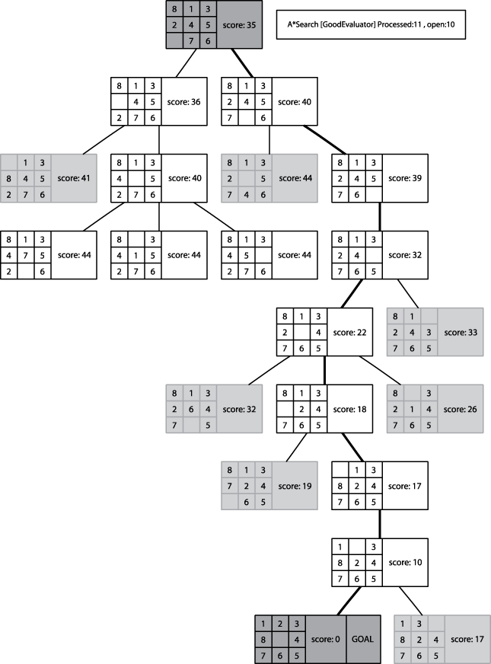

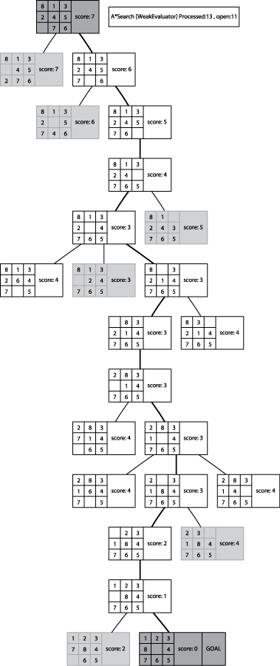

| **Measure name** | **Description of h*(n)** | **Evaluation of h*(n)** | **Statistics** |
| --- | --- | --- | --- |
| GoodEvaluator | P(n) + 3*S(n), where P(n) is the sum of the Manhattan distances that each tile is from "home." S(n) is a sequence score that checks the non-central squares in turn, allotting 2 for every tile not followed by its proper successor and 0 for every other tile, except that a piece in the center scores 1. | 13+3*11=46 | 13-move solution  closed:14  open: 12 |
| WeakEvaluator | Count number of misplaced tiles. | 7 | 13-move solution  closed:145 open:110 |
| BadEvaluator | Take differences of opposite cells (across from the center square) and compare against the ideal of 16. Ignore blank cell. | (7−0) + (6−8) + (5−4) + (2−1) = 7  Score is |16-7|=9 | 421-move solution  closed: 2499  open: 1583 |